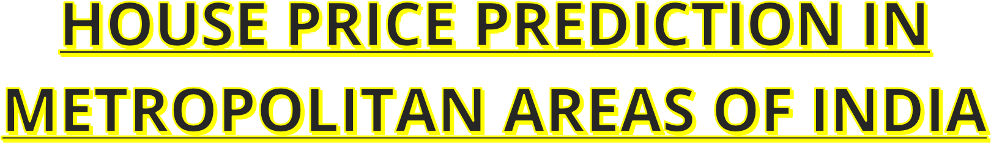



**TEAM LEAD : KODIPATINA NAVYA VARSHINI**

TEAM MEMBER : KORAPAKA PRUDHVI RAJ

TEAM MEMBER : KOPPOJU GEETHA

TEAM MEMBER : MAHANTY SILPA

TEAM MEMBER : MADHUPADA SAMPATH RAJU

# House Price Prediction In Metropolitan

**Areas Of India :**

House price prediction in a metropolitan city in India is a valuable solution for potential home buyers, real estate agents, and investors.

By leveraging historical sales data, property details, and locationspecific information, a predictive model can accurately estimate house prices. The model's scalability, real-time updates, user-friendly interface, and transparency ensure it meets the needs of stakeholders. Integration capability, data privacy, and costeffectiveness are also important considerations. By addressing these requirements, the prediction model provides reliable insights, empowering stakeholders to make informed decisions in the fastpaced real estate market.

[**Housing prices in India surged**](https://timesproperty.com/news/post/housing-prices-surge-in-41-cities-blid6207) by approximately 20 per cent over the past two years (2021-2023), fueled by robust demand and a positive economic outlook. This growth was particularly evident in cities like Bengaluru, [**Delhi**](https://timesproperty.com/property-in-delhi-mcid-11) NCR, and Kolkata, which witnessed price increases of around 30 per cent during the same period.

**Surge in Demand for Mid-Segment and Luxury Properties:**

The report by CREDAI, Colliers, and Liases Foras revealed that the rise in housing prices was driven by a significant increase in demand, particularly for mid-segment and luxury properties. This demand stemmed from several factors, including:

* **Favourable interest rates:** The low-interest-rate environment made it easier for potential buyers to secure home loans, thereby increasing affordability.
* **Positive economic outlook:** A strong economic outlook, coupled with rising income levels, boosted buyer confidence and willingness to invest in real estate.
* **Increased urbanisation:** The ongoing trend of urbanisation in India also contributed to the rise in demand for housing, especially in major cities.

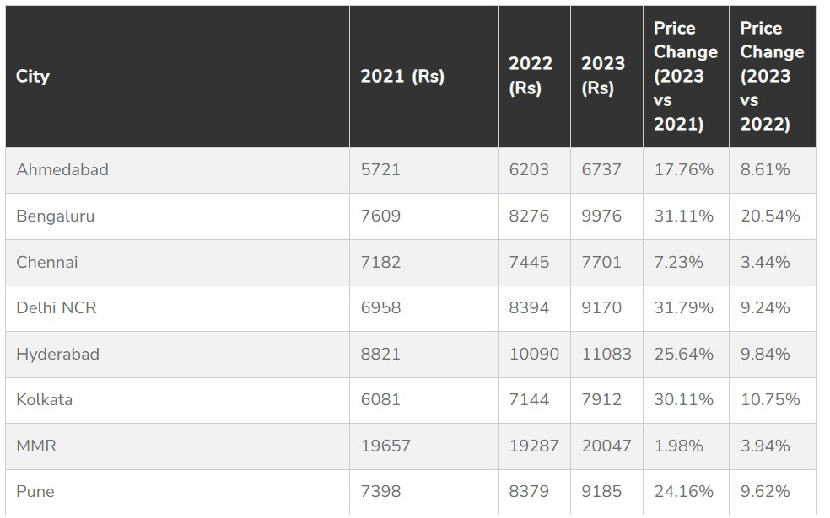

**Bengaluru Leads the Way:**

Among the major cities analysed, Bengaluru emerged as the frontrunner with a remarkable 31 per cent increase in housing prices during the period 2021-2023. This growth was attributed to heightened residential activity, particularly near IT hubs like Whitefield, KR Puram, and Sarjapur. Additionally, the city witnessed a significant surge in new launches, especially in the luxury and ultra-luxury segments.

**Kolkata Property Market Sees 17 Per Cent Rise In Apartment Registration**

[**s**](https://timesproperty.com/news/post/kolkata-property-market-sees-17-per-cent-rise-in-apartment-registrations-blid7386)

The Kolkata Metropolitan Region (KMR) witnessed a positive trend in its property

market with a 17 per cent yea

[r](https://timesproperty.com/news/post/kolkata-property-market-sees-17-per-cent-rise-in-apartment-registrations-blid7386)

[-](https://timesproperty.com/news/post/kolkata-property-market-sees-17-per-cent-rise-in-apartment-registrations-blid7386)

[o](https://timesproperty.com/news/post/kolkata-property-market-sees-17-per-cent-rise-in-apartment-registrations-blid7386)

[n](https://timesproperty.com/news/post/kolkata-property-market-sees-17-per-cent-rise-in-apartment-registrations-blid7386)

[-](https://timesproperty.com/news/post/kolkata-property-market-sees-17-per-cent-rise-in-apartment-registrations-blid7386)

year (YoY) growth in apartment

registrations during

March 2024. This data comes from a recent report by Knight Frank India, a real estate

consultancy firm

[.](https://timesproperty.com/news/post/kolkata-property-market-sees-17-per-cent-rise-in-apartment-registrations-blid7386)



[**Hyderabad**](https://timesproperty.com/news/post/real-estate-prices-soar-hyderabad-leads-with-33-percent-increase-blid6117) also experienced significant growth in its real estate market, with housing prices rising by 26 per cent over the past two years. This surge was primarily driven by a substantial influx of luxury property supply and unwavering confidence among homebuyers. Notably, the Southwest sub-market in Hyderabad witnessed the highest price hike, at 24 per cent year-on-year.

**Overall Market Trends and Outlook:**

Despite the significant increase in new launches, the unsold inventory in key cities like Delhi NCR, Chennai, and Pune saw a notable decrease during the 2021-2023 period. This indicates a healthy absorption of available housing stock.

Experts predict that the Indian housing market is likely to maintain its upward trajectory in 2024, with the mid-segment and [**luxury segments**](https://timesproperty.com/news/post/luxury-homes-lead-housing-market-surge-blid5363) expected to continue thriving and offering lucrative opportunities for investors and homebuyers alike. This positive outlook is based on factors like:

* **A healthy balance between sales, supply, and price growth:** The current market scenario, where sales, supply, and prices are all experiencing positive growth, signifies a balanced and healthy real estate environment.
* **Expected rise in income levels:** As income levels are expected to rise steadily, the demand for housing is likely to remain strong in major cities.

Overall, the [**Indian real estate market**](https://timesproperty.com/news/post/an-upswing-in-indian-real-estate-sector-expected-in-2024-blid6321) is currently displaying a robust picture, with strong demand, a positive economic outlook, and balanced growth across various segments. This scenario is expected to continue in the near future, making it an attractive market for both investors and homebuyers.

Technical Architecture :

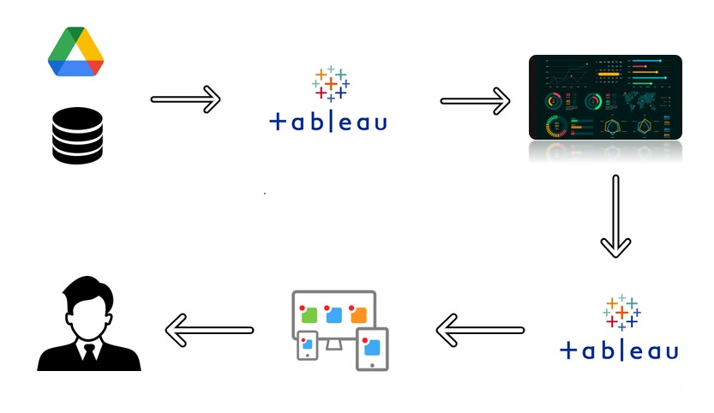

## Pre-Requisites

For Completing this project these are some of the prerequisites needed

* A system with a minimum 4GB RAM and 128GB Hard Disk
* Good Internet Connection
* Google Drive / Any of the Database Server with Management Studio
* MySQL:
* **SQL Server Management Studio:**
* **Tableau Desktop:**
* Tableau Public Account: <https://public.tableau.com/app/discover>
* Html, CSS or Bootstrap

## Prior-Knowledge

To Complete this project, one must understand the below concepts and able to work with the tools

* **Data Visualization: To create a perfect visualizations first we need to understand the data whatever it is and use prefect**

**measures and parameters to create perfect Visualizations.**

**They are lots of Visualizations we would like to discuss some of them in below**

* **Chart Types:**

**1.pie chart :-** [A common, but limited, visualization used to show how a few dimensions compare to one another and the whole.](https://www.tableau.com/data-insights/reference-library/visual-analytics/charts/pie-charts)

**2.bar chart:-** [Used to categorize elements based on size. Can be ordered or unordered based on the nature of the dimensions.](https://www.tableau.com/data-insights/reference-library/visual-analytics/charts/bar-charts)

**3.Line chart:-** [Best used to show trends across time intervals. Multiple lines can be used to compare categories within a dimension.](https://www.tableau.com/data-insights/reference-library/visual-analytics/charts/line-charts)

**4.Scatterplot:-**[Used to explore the correlation between two measures with independent axes. Often combined with trendlines.](https://www.tableau.com/data-insights/reference-library/visual-analytics/charts/scatter-plots)

**5.Histogram:-** [Histograms split a single continuous measure into bins, or groups, to analyze distribution.](https://www.tableau.com/data-insights/reference-library/visual-analytics/charts/histograms)

**6.Bullet graph:-** [A bullet graph takes a bar chart and adds additional elements to create a compact way to analyze performance against a goal or threshold.](https://www.tableau.com/data-insights/reference-library/visual-analytics/charts/bullet-graphs)

**7.Packed Bubble chart:-**[A packed bubble chart uses size as the primary visual element to allow for comparison between categories.](https://www.tableau.com/data-insights/reference-library/visual-analytics/charts/packed-bubbles)

**8.Box & Whisker:-** [A box and whisker plot shows the range of values along with the average and interquartile ranges.](https://www.tableau.com/data-insights/reference-library/visual-analytics/charts/box-whisker)

**9.Treemaps:-** [A treemap breaks the whole into its parts using a quantitative measure to determine the size of each square.](https://www.tableau.com/data-insights/reference-library/visual-analytics/charts/treemaps)

**10.Line chart:-** [Best used to show trends across time intervals. Multiple lines can be used to compare categories within a dimension.](https://www.tableau.com/data-insights/reference-library/visual-analytics/charts/line-charts)

* **Univariate, Bi- Variate and Multi-Variate Analysis:- Univariate** statistics summarize only **one** [**variable**](https://www.scribbr.com/methodology/types-of-variables/) at a time.

**Bivariate** statistics compare **two variables**.**Multivariate** statistics compare **more than two variables**.

**Tableau:** Tableau was founded in 2003 as a result of a computer science project at

Stanford that aimed to improve the flow of analysis and make data more accessible to people through visualization. Co-founders Chris Stolte, Pat Hanrahan, and Christian Chabot developed and patented Tableau's foundational technology, VizQL—which visually expresses data by translating drag-and-drop actions into data queries through an intuitive interface. Since our foundation, we’ve continuously invested in research and development at an unrivaled pace, developing solutions to help anyone working with data to get to answers faster and uncover unanticipated insights.

* **Business Intelligence:-** Business intelligence combines business

analytics, data mining, [data visualization,](https://www.tableau.com/learn/articles/data-visualization) data tools and infrastructure, and best practices to help organizations make more data-driven decisions. In practice, you know you’ve got [modern business intelligence](https://www2.deloitte.com/content/dam/Deloitte/tr/Documents/deloitte-analytics/Modern%20Business%20Intelligence.pdf) when you have a comprehensive view of your organization’s data and use that data to drive change, eliminate inefficiencies, and quickly adapt to market or supply changes. Modern BI solutions prioritize flexible self-service analysis, governed data on trusted platforms, empowered business users, and speed to insight.

# Project Objectives

By the end of this project, you will:

* Able to Connect Tableau with different data sources
* Know fundamental concepts and techniques used for Data Visualization.
* Gain a broad understanding about data and different types of charts.
* Have knowledge of developing Visualizations, Dashboards and Story.
* Able to Integrate the developed dashboard and story with the web application

# Project Flow

To accomplish this, we have to complete all the activities listed below,

* Data collection o Collect the dataset and save it as project name after that upload the data in tableau.

o Make some modifications in that data. o Use some operations like union or intersection etc. o Coming to my project work we merge the data into a single data set using union operation save the data set in your desktop.

* Database /Spreadsheet Connection
  + After uploading the data set understand the data and make modifications what do you want after that click save to save the modifications. o Make some parameters to create visualizations easy and use different type of data to create different types of visualizations. o Connect Tableau Desktop to Database server.
  + Before connecting the data into the database server check it once and after that upload into the server. o Visualizations we created
* pie chart, [A common, but limited, visualization used to show how a few dimensions compare to one another and the whole.](https://www.tableau.com/data-insights/reference-library/visual-analytics/charts/pie-charts)
* bar chart[,Used to categorize elements based on size. Can be ordered or unordered based on the nature of the dimensions.](https://www.tableau.com/data-insights/reference-library/visual-analytics/charts/bar-charts)
* Line chart, [Best used to show trends across time intervals. Multiple lines can be used to compare categories within a dimension.](https://www.tableau.com/data-insights/reference-library/visual-analytics/charts/line-charts)
* Scatterplot, [Used to explore the correlation between two measures with independent axes. Often combined with trendlines.](https://www.tableau.com/data-insights/reference-library/visual-analytics/charts/scatter-plots)
* Histogram, [Histograms split a single continuous measure into bins, or groups, to analyze distribution.](https://www.tableau.com/data-insights/reference-library/visual-analytics/charts/histograms)
* Bullet graph,[A bullet graph takes a bar chart and adds additional elements to create a compact way to analyze performance against a goal or threshold.](https://www.tableau.com/data-insights/reference-library/visual-analytics/charts/bullet-graphs)
* Packed Bubble chart [A packed bubble chart uses size as the primary visual element to allow for comparison between categories.](https://www.tableau.com/data-insights/reference-library/visual-analytics/charts/packed-bubbles)
* Box & Whisker, [A box and whisker plot shows the range of values along with the average and interquartile ranges.](https://www.tableau.com/data-insights/reference-library/visual-analytics/charts/box-whisker)
* Treemaps, [A treemap breaks the whole into its parts using a quantitative measure to determine the size of each square.](https://www.tableau.com/data-insights/reference-library/visual-analytics/charts/treemaps)
* Line chart, [Best used to show trends across time intervals. Multiple lines can be used to compare categories within a dimension.](https://www.tableau.com/data-insights/reference-library/visual-analytics/charts/line-charts)
* Visualizing and analyzing data
* Understand the Data and the Business Questions
* Based on the Business questions develop the different visualizations
* Dashboard o Develop the Dashboard by using various visualizations and name it as related data
  + - It is one of the best way to understand and easy to learn and easy to explain to others
    - After saving the dashboard it is very important to publish dashboard in tableau public because it easy to copy the code for web integration and downloading is very easy. o Before publishing the data into the tableau public to create a account in tableau public after that go to publish work book by clicking publish workbook option.
    - This process is same for every dashboard and story. o No worries to create multiple times account creation only once done it is over for every time it will ask to login.
    - After publishing the dashboard into the public account we will go to the right side top by clicking share option we will see a popup page by clicking embed code the code will be copied.
* Story o In story also same process as we discussed in the above but some slight changes are there in dashboard single page contains 4 or more visualizations but in this one single sheet contains only one visualization. o By clicking add,a new sheet will be opened in story page and we will add minimum of 7 visualizations to create perfect story.

o After completing the story we will publish the story into the tableau public.

* Publishing to the Tableau Public & Web Application Integration o Developed Visualizations, Dashboard and story will be published to Tableau Public Account. o Once it is published, we will get the shareable links o Develop a web application using HTML, CSS or Using Bootstrap o Integrate the Visualizations, Dashboard and Story with the Web Application

## Data Collection & Extraction From Database

* Data collection is the process of gathering and measuring information on variables of interest, in an established systematic fashion that enables one to answer stated research questions, test hypotheses, evaluate outcomes and generate insights from the data.
* After collecting the data it is in csv format we would like to convert it into excel or any other format and we will remove unwanted data and we would like to add any other information about these cities.

## Collect The Dataset

Please use the link to download the dataset: This data set contains all the information about 6 cities in india they are hyderabad,mumbai,Kolkata,Chennai,delhi,bengalore.

This information contains all the data about these 6 cities and we would like to create any visualizations . https://www.kaggle.com/datasets/ruchi798/housing-prices-in-metropolitan-areas-of-india

# Understand the data

Data contains all the meta information regarding the columns described in the CSV files

## Data Visualization

Data visualisation is the graphical representation of information and data. By using visual elements like charts, graphs and maps, data visualisation tools provide an accessible way to see and understand trends, outliers and patterns in data.

In the world of big data, data visualisation tools and technologies are essential for analysing massive amounts of information and making data-driven decisions.

They are some visualizations we created using tableau :-

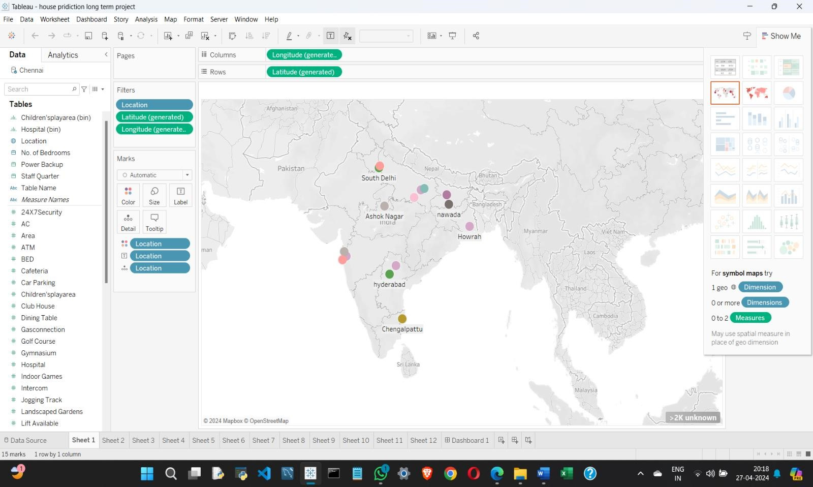

**Cities For Real Estate Investment**

Now that we know the factors to consider, let's explore India's top cities for real estate investment.

### 1. Bangalore

- The Silicon Valley of India: Bangalore consistently ranks high in real estate investment. This is due to its thriving IT sector and a steady influx of professionals. Areas like Whitefield, Electronic City, and Sarjapur promise investment opportunities. This has led to consistent growth in property values in these regions. Apartments, especially in gated communities, are popular among investors and end-users alike.

### 2. Mumbai

- The Financial Capital: The city of dreams is a prime choice for property investment. Mumbai promises a cosmopolitan lifestyle and business

opportunities. Here, areas like Bandra, Powai, and Thane are attractive options for investors. However, the market can be price-sensitive, and high demand often leads to premium prices, making it important for investors to conduct thorough research before investing. Despite the constant supply of new properties, the demand for real estate in Mumbai often outstrips supply, leading to consistent price appreciation. Limited availability of land and strict regulations on construction also contribute to this demand-supply imbalance.

### 3. Gurgaon

- The Posh Hub: Gurgaon's strategic location near the national capital, New Delhi, is a significant advantage. It offers easy access to the central business districts of Delhi, making it attractive for professionals and businesses alike. Commuting to Delhi is relatively convenient via well-maintained road networks and the Delhi Metro. Gurgaon offers a wide range of residential options, from luxurious apartments and villas to affordable housing projects.

### 4. Hyderabad

- The Emerging Tech Hub: Hyderabad's growth as an IT and business hub is boosting its real estate market. Areas like HITEC City and Kondapur have witnessed substantial growth in property values. If you are looking to invest, this can be the right place for you. Commercial office spaces, as well as [residential properties,](https://www.adanirealty.com/residential-projects) have been in high demand.

### 5. Chennai

- The Manufacturing Hub: Chennai's industrial base and educational institutions make it an attractive destination for real estate investment. Areas like OMR and Guindy offer promising returns. The affordable cost of living and a relatively stable market make Chennai more friendly for investors.

### 6. Pune

- The Education Hub: Pune has a thriving education sector and a growing IT industry. These factors drive real estate demand. Localities like Hinjewadi and Kharadi are hotspots for property investment. Integrated townships and modern amenities are significant trends in Pune's real estate market. The city has seen significant infrastructure development, including road improvements, flyovers, and metro rail projects. These developments have enhanced connectivity and accessibility, further boosting the real estate market.

### 7. Kolkata

- The Cultural Capital: Kolkata's charm and affordability make it an emerging real estate market. Areas like Rajarhat and New Town offer good investment opportunities. The city has witnessed a rise in affordable housing projects.

### 8. Ahmedabad

- The Commercial Hub: Ahmedabad has a stable economy and business-friendly environment. Localities like Vastrapur and Prahlad Nagar show growth potential. The city has seen significant infrastructure development, which has given a

further push to its real estate market. Explore [property for sale in Ahmedabad](https://www.adanirealty.com/property-in-ahmedabad) today.

### 9. Kochi

- The Coastal Beauty: Kochi is not only impressive for its scenic beauty, but the port city also attracts real estate investors. Areas like Kakkanad and Edapally offer good investment options. Its real estate market is continuously expanding, making it a favourable choice for new investors.

### 10. Jaipur

- The Pink City: Jaipur has a rich history and cultural heritage. These factors are contributing to its real estate growth. Areas like Vaishali Nagar and Jagatpura are witnessing increased investment. The city's scenic beauty also makes it an appealing destination for second-home buyers.

VISUALIZATION 1 – PIE CHART

AREA WISE POPULTION IN CITIES

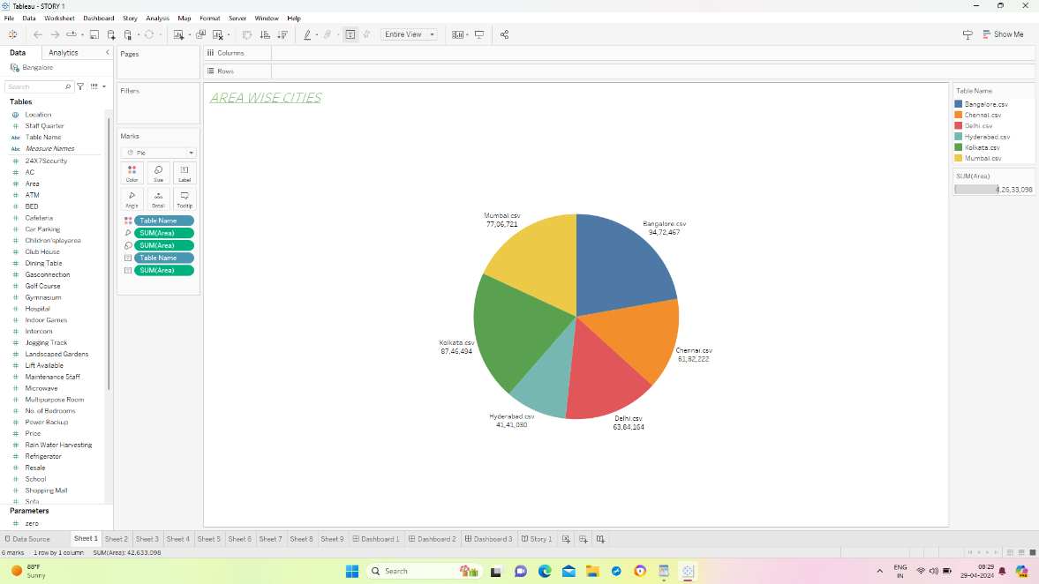

FIELDS WE HAVE USED : 1. Area

2. table name

HERE IS THE DATA OF CITIES WHICH HAS MORE AREA UNDER IN IT AND THE TOTAL POPULATION OF THE HIGHEST HOUSE PRICES IN METROPOLITICIAN CITIES. IT SHOWS THE NUMERICAL VALUE OF THE AREAS IN THE GIVEN CITIES. THE GIVEN CITIES ARE CHENNAI , MUMBAI , BANGLORE , KOLKATA , DELHI, HYDERABAD.

VISUALIZATION 2 – GEOGRAPHICAL MAPS

THE HIGHEST HOUSE PRICES IN METROPOLITAN AREAS OF INDIA

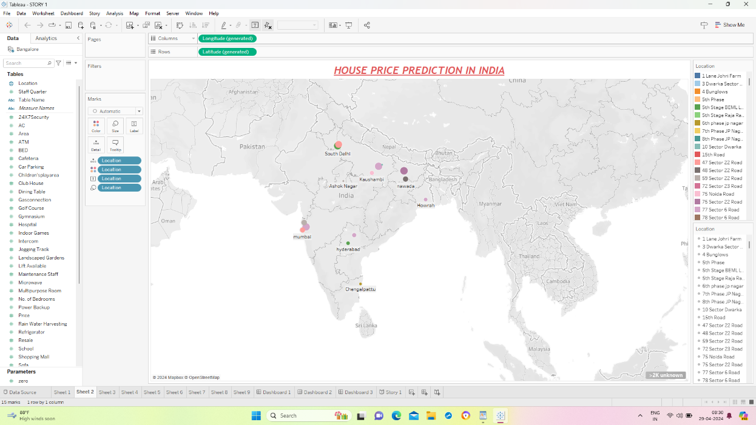

FIELDS WE HAVE USED ARE : 1. Geographical location

This is the information about the highest house prices In metropolitan areas of India where the house prices are very high . the highest house prices in India are Mumbai, Chennai, Kolkata , Hyderabad, Pune, Delhi, Banglore. We have use the shapes , color, size filter for the geographical map to show the visualization more colourfully.

VISUALIZATION 3 – TREE MAP

NO OF STAFF QUARTERS IN DIFFERENT AREAS

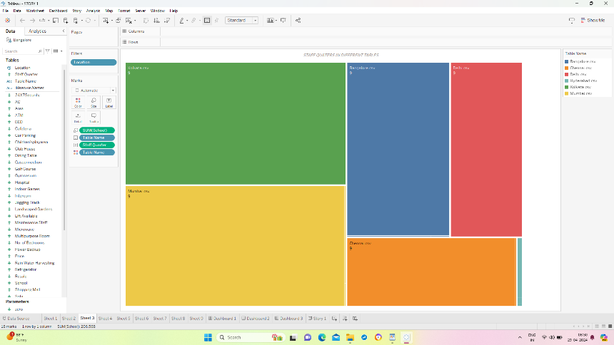

FIELDS WE HAVE USED AREA – 1. Number of schools

2. number of staff quarters

3. table name

This is the information about the highest to lowest house prices in India and it also includes the total number of schools in their respective cities. The highest city is Kolkata and the lowest city is Hyderabad compared to the 6 cities which we have In the list.

VISUALIZATION 4 – BAR CHART

PRICES IN DIFFERENT AREAS

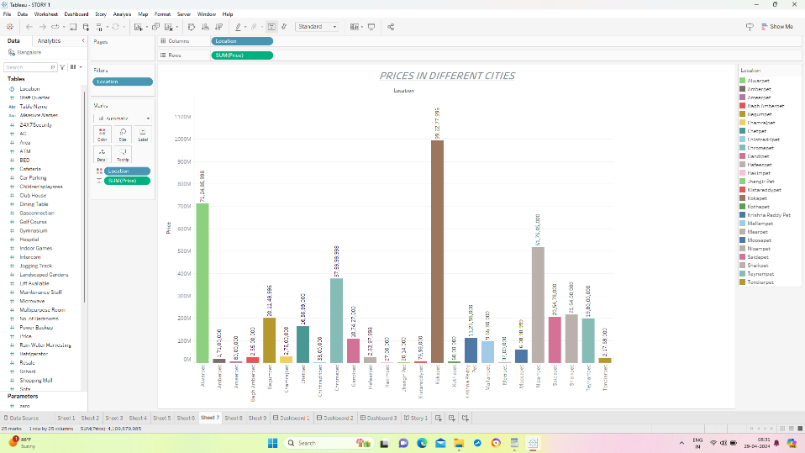

FIELDS WE HAVE USED ARE : 1. Location

2. prices

This is the information of house prices in several areas where the area name ends with pet. The visualization shows the total prices of the areas . the highest area is Kokapet and the lowest area is Jhangirpet comparatively to the area names wich end with pet.

VISUALIZATION 5 – HORIZONTAL BAR CHART

HIGHEST HOUSE PRICES OF METROPOLITAN CITIES

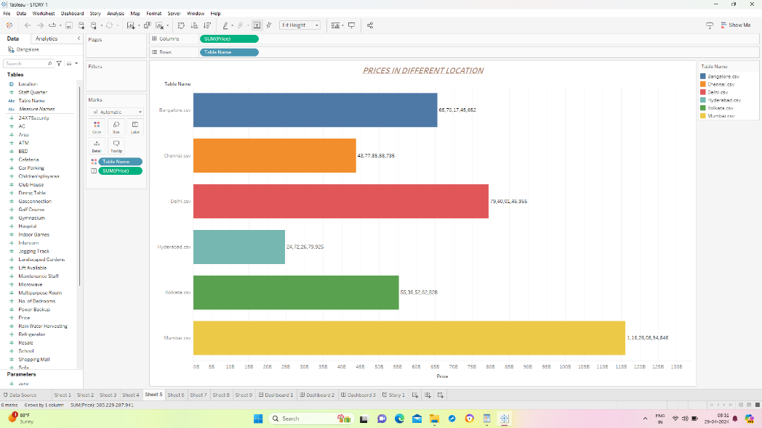

FIELDS WE HAVE USED ARE – 1. Table name

2. prices

Here is the information of the highest house prices in metropolitan area of India . the horizontal bar represent the cities and the x axis represent the prices in billions. The highest house prices is Mumbai with 116B and the lowest is Hyderabad with 27B.

|  |  |  |  |
| --- | --- | --- | --- |
| Furthermore, the Indian real estate sector is anticipated to achieve a market size of US$ 1 trillion by 2030, | | | |
| a considerable rise from US$ 200 billion in 2021, with an | | expected contribution of 13% to the country's |  |
| GDP by 2025 | . | |

Average home prices in India are set to rise 7% this year and next, driven by purchases of luxury properties. The housing market has powered along with Asia's No. 3 economy, facing challenges of stagnant wages, poverty, and a gap between demand and supply of affordable homes.

|  |  |  |  |
| --- | --- | --- | --- |
| Pune | is India's most affordable and preferred metro city in the real estate market (During H1 2023 | | |
| Mumbai | | . Popularly known as the city of dreams, Mumbai has long been considered a real estate market | | |
| hub in India, whether it be for residential or even commercial property. | | |  | |

Mumbai Is India's Most Expensive CitY.

VISUALIZATION 6 – PACKED BUBBLES

AREA WISE HOSPITALS

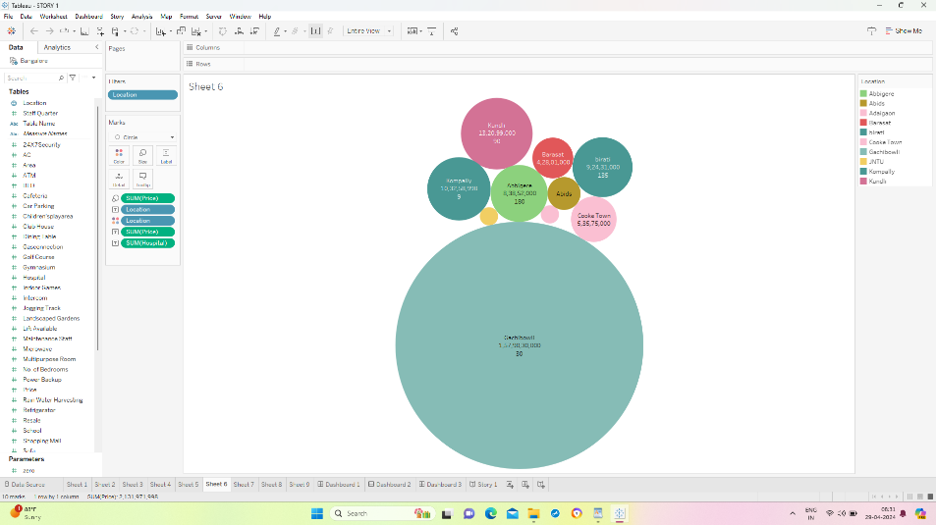

FIELDS WE HAVE USED ARE – 1. Location

2. prices

3. number of hospitals

Here Is the information about the total number of hospitals in the area where the area name ends with nagar. Each bubble represent the each area and the total number of hospitals in that area and bubbles are sized according to the highest to lowest number of hospitals.

VISUALIZATION 7 – DONUT CHART

HIGH SECURITY IN DIFFERENT CITIES

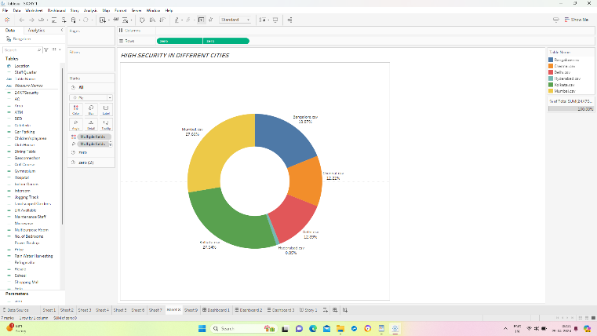

FIELDS WE HAVE USED ARE : 1. Table name

2. high security

Here is the information about the highest security of all the cities in percentages . the highest security in India is Mumbai with 27.69% and the lowest security is Hyderabad with 0.85% .

VISUALIZATION 8 - CIRCLE CHART

RATE OF CARPARKING IN DIFFERENT LOACTIONS

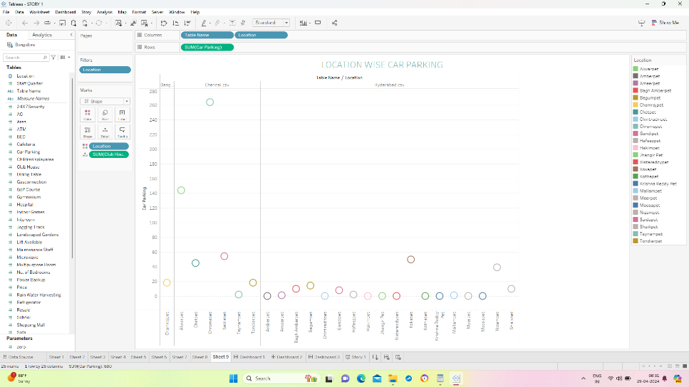

FIELDS WE HAVE USED ARE – 1. location

2. car parking

3. club house

Here is the information about the highest carparking and club houses of area of certain cities where the area name ends with pet . the horizontal or x axis represent the area names which ends with pet and the vertical line or y axiz represents the carparking. The highest car parking is chorampet with 260 .

## Dashboard

A dashboard is a graphical user interface (GUI) that displays information and data in an organized, easy-to-read format. Dashboards are often used to provide real-time monitoring and analysis of data and are typically designed for a specific purpose or use case. Dashboards can be used in a variety of settings, such as business, finance, manufacturing, healthcare, and many other industries. They can be used to track key performance indicators (KPIs), monitor performance metrics, and display data in the form of charts, graphs, and tables.

DASHBOARD 1 –

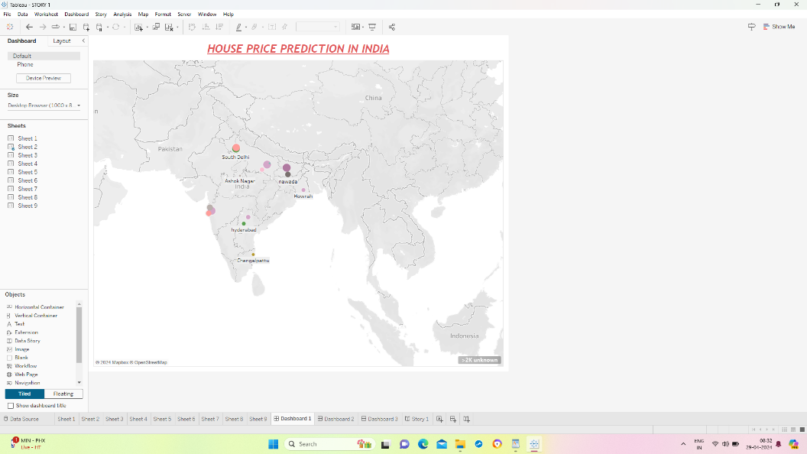

HOUSE PRICE PREDICTION IN METROPOLITAN AREA OF INDIA

Here the dashboard consists of 1 visualization of geographical map which shows the cities of highest house prices in India.

DASHBOARD 2

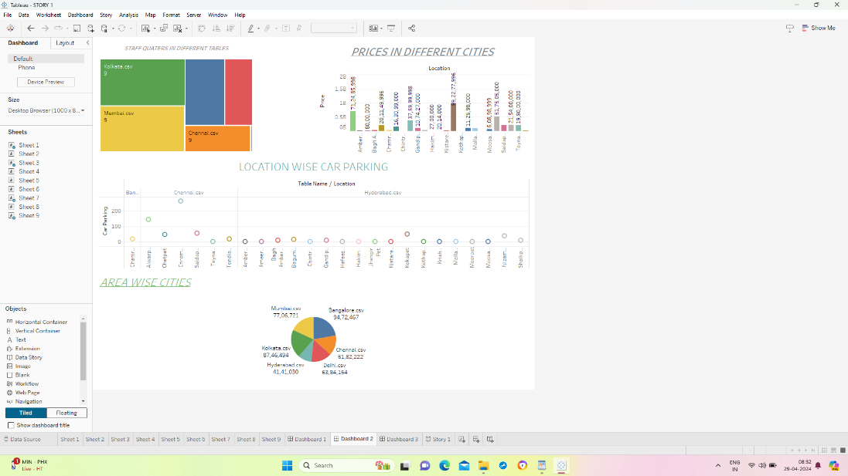

DASHBOARD 2 CONSISTS OF 4 VISUALIZATION

1. TREEMAP – STAFF QUARTERS IN DIFFERENT CITIES
2. BAR CHART – PRICES IN DIFFERENT AREAS
3. CIRCLE CHART –RATE OF CARPARKING IN DIFFERENT LOCATIONS
4. PIE CHART – AREA WISE POPULATION IN CITIES

DASHBOARD 3

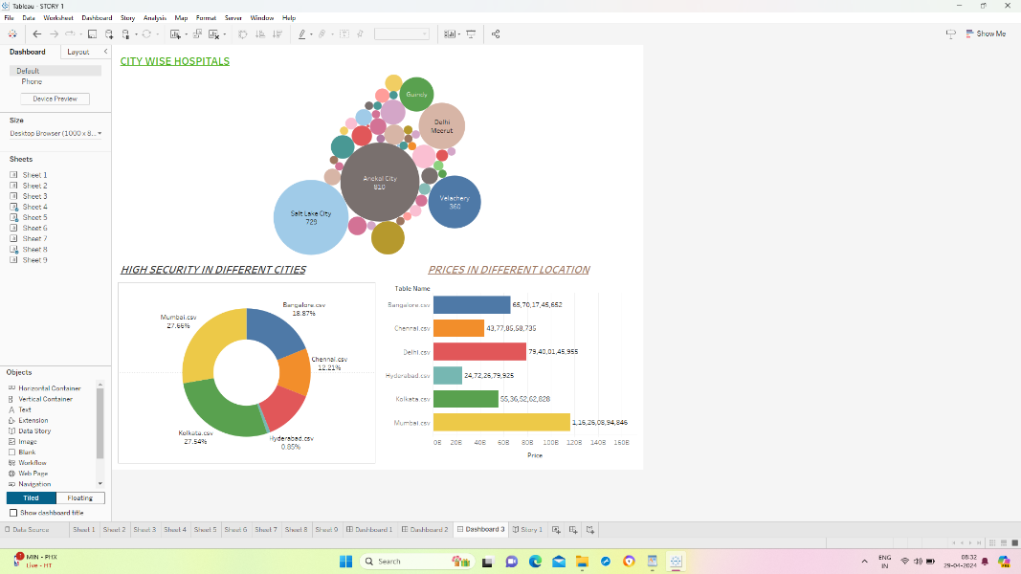

DASBOARD 3 CONSISTS OF 3 VISUALIZATION

1. BUBBLE CHART – CITY WISE HOSPITALS
2. DONUT CHART – HIGH SECURITY IN DIFFERENT CITIES
3. HORIZONTAL BAR CHART – PRICES IN DIFFERENT CITIES

## Story

A data story is a way of presenting data and analysis in a narrative format, intending to make the information more engaging and easier to understand. A data story typically includes a clear introduction that sets the stage and explains the context for the data, a body that presents the data and analysis logically and systematically, and a conclusion that summarizes the key findings and highlights their implications. Data stories can be told using a variety of mediums, such as reports, presentations, interactive visualizations, and videos.

Here is the link to see the story : <https://drive.google.com/file/d/1OztdR2l59Y1p5VXzBYYnZQJtMr8I2KlO/view?usp=drivesdk>

## Web Integration

Publishing helps us to track and monitor key performance metrics and to communicate results and progress. help a publisher stay informed, make better decisions, and communicate their performance to others.

Publishing dashboard and reports to tableau public

**Step 1: Go to Dashboard/story, click on the share button on the top ribbon**

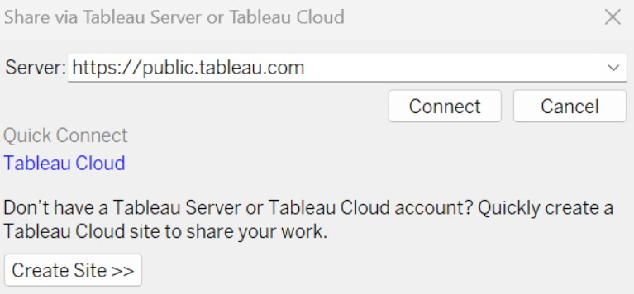

Give the server address of your tableau public account and click on connect.

Explanation

Video:- <https://drive.google.com/file/d/1NWvfMUtzA20GMxJMk9i6370FkSlBKGuK/view?usp=drivesdk>

**Step 2: Once you click on connect it will ask you for the tableau public username and password**

Once you login into your tableau public using the credentials, the particular visualization will be published into the tableau public

**Note: While publishing the visualization to the public, the respective sheet will get published when you click on the share option.**

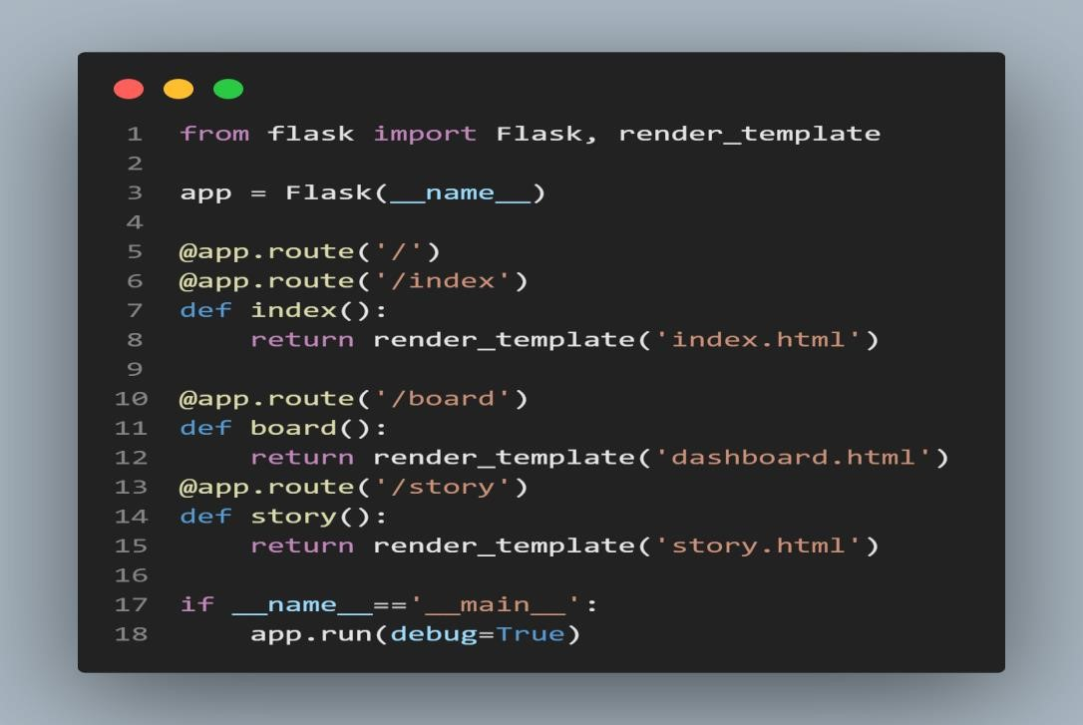

### Economic Expansion

India’s economy has shown resilience and steady growth, attracting global and domestic investors. This economic prosperity translates into increased purchasing power and investor confidence, fueling demand across the residential, commercial, and retail real estate sectors. As the economy continues to grow, the real estate market is expected to benefit from heightened activity and investment.

### Migration to Urban Areas

Rapid urbanization is a key driver of the real estate market in India. The migration of people from rural to urban areas in search of better employment opportunities and living standards has led to a surge in demand for housing and commercial spaces in cities. This trend is expected to persist, further straining the urban infrastructure and housing supply, thereby creating numerous investment opportunities in urban development projects.

### Young Population

India’s demographic profile is characterized by a large, young population that is entering the workforce and has a growing aspiration for homeownership and quality living spaces. This demographic trend is boosting demand for modern, amenity-rich residential properties, as well as for retail and office spaces, as more young professionals seek better lifestyles and work environments.

### A Growing Middle-Class

The expanding middle class in India, with its increasing disposable income, is a significant contributor to the real estate demand. This segment is actively investing in property as a means of securing financial stability and improving living standards, driving the development of both affordable and premium housing projects.

### IT Sector Expansion

The rapid growth of the IT and services sectors has had a transformative impact on the real estate market, particularly in cities like Bangalore, Hyderabad, and Pune. The demand for office spaces, residential properties, and serviced apartments has skyrocketed, driven by the influx of professionals and the expansion of these industries.

### Government Initiatives

The Indian government’s introduction of regulatory reforms such as the Real Estate

(Regulation and Development) Act (RERA) and affordable housing schemes under the Pradhan Mantri Awas Yojana (PMAY) has increased transparency and accountability in the real estate sector. These initiatives have bolstered investor confidence and made the market more attractive for both domestic and international investors.

### Rental Income

Properties in emerging cities offer attractive rental yields, making them appealing for investors looking for steady income streams in addition to capital appreciation. The growing demand for rental housing, especially from the young working population and students, ensures a robust rental market, providing investors with lucrative and stable returns. These factors collectively make India’s real estate market ripe for investors seeking to capitalize on the potential for substantial returns.

Key Factors for Choosing the Best City

### Economic Stability

Cities with a strong economic base offer more resilience against market fluctuations. A stable job market, presence of multinational companies, and diverse industries contribute to economic health, making these cities safer bets for long-term investments.

### Population Growth

Rapidly growing cities indicate a rising demand for housing and commercial spaces. Urban centers that attract people for employment and better living standards typically see a surge in real estate demand, driving up property values.

### Infrastructure Development

Well-developed infrastructure, such as roads, public transport, utilities, and connectivity, enhances a city’s appeal for living and business. Cities investing in infrastructure projects often experience a positive impact on real estate prices and investment returns.

### Real Estate Market Trends

Understanding local market trends, including the rate of property appreciation, rental yields, and vacancy rates, is crucial. Cities showing consistent growth in these areas are likely to offer better investment opportunities.

### Quality of Life

Cities that score high on quality of life parameters, including safety, healthcare, education, and recreational facilities, tend to attract more residents and retain them. This, in turn, sustains demand for real estate, making such cities attractive for investors.

Top Cities for Real Estate Market Investment

### Mumbai

Popularly known as the city of dreams, Mumbai has long been considered a real estate market hub in India, whether it be for residential or even commercial property. Offering an unapologetically urban lifestyle along with many career opportunities, this is a prime choice when it comes to choosing a city for real estate investment. The financial capital of the country has so much to offer with regards to potential for property appreciation and high ROI. Mumbai is also a major destination when it comes to luxury residential real estate, with reputed builders like L&T Realty having developed a number of [top residential projects](https://www.lntrealty.com/residences) in the city.

### Bangalore

Bangalore is another one of the major urban hubs of the country, with the immense growth in its IT industry and rapidly improving infrastructure. With the increasing amount of commercial investment in different parts of the city as well as the notable growth of its residential real estate market, Bangalore offers great return of investment. Its ever-growing status as an IT hub and its substantial influx of young professionals make Bangalore a fantastic option for real estate investors. The city also has its fair share of luxury residential developments by top developers, including Raintree Boulevard by L&T Realty, which offers 3 and [4 BHK flats in Hebbal.](https://www.lntrealty.com/residences/flats-in-hebbal-raintree-boulevard-bengaluru/)

### Pune

Pune happens to be another city that has rapid expansion of its IT industry. Investing in Pune’s real estate is a wise decision due to this boom as well as the growth in its automotive industries, both of which attract a skilled workforce and foster economic growth. The city’s excellent educational institutions make it an educational hub, further increasing its residential appeal. With ongoing infrastructure development and a high quality of life, Pune offers the strong rental yields and investment value growth property investors are looking for.

### Hyderabad

The third IT hotspot on this list, Hyderabad’s real estate market is ripe for investment, thanks to its status as a burgeoning tech and business hub, attracting professionals nationwide. The city has immense offerings including robust infrastructure, metro connectivity, and relatively affordable property rates compared to other metro cities in the country. With significant government initiatives promoting development and a better quality of life, Hyderabad offers promising investment appreciation and rental yields for real estate investors.

### Chennai

Chennai’s real estate market offers intriguing investment opportunities due to its diverse economic base, which include IT, manufacturing, as well as healthcare sectors. The city’s fantastic coastal location enhances its logistic and commercial allure. With a strong educational ecosystem, well-developed infrastructure, and cultural heritage, Chennai offers a stable market with appreciating real estate values and a notable increase in residential properties by reputed developers. One of these properties is Avinya Enclave by L&T Realty, housing lavish 2, 3, and [4 BHK apartments in Manapakkam.](https://www.lntrealty.com/residences/avinya-enclave-2-3-4-bhk-flats-in-manapakkam-chennai/)

### Delhi-NCR

Delving into Delhi-NCR’s real estate market is an attractive idea due to its status as India’s political and business heartland, boasting impressive connectivity and infrastructural development. The area’s diverse economy, largely backed by IT, commerce, and manufacturing, drives notable demand for residential and commercial real estate. With ongoing infrastructure projects that aim to improve overall connectivity, Delhi-NCR offers substantial growth potential, property value appreciation, and lucrative rental yields for those looking to invest.

### Navi Mumbai

Navi Mumbai has emerged as a meticulously planned satellite city to help provide some relief for the city of Mumbai, offering a cleaner and less congested environment. Its welldeveloped infrastructure, including seamless access to Mumbai via rail as well as road networks, and upcoming projects like the Navi Mumbai International Airport, greatly boost its real estate standing. The city has also attracted many reputed real estate developers such as L&T Realty, who offer a luxurious residential property with the [Seawoods Residences.](https://www.lntrealty.com/residences/2-3-bhk-flats-in-seawoods-navi-mumbai/)

### Jaipur

Jaipur, with its fantastic location at the heart of Rajasthan, is beginning to stand out as a point of interest when it comes to real estate investment. The city’s impressive infrastructure improvements, which includes expansions to its metro and enhanced connectivity, has further elevated its real estate market. Jaipur’s growing tech and tourism sectors have contributed to a high demand for both residential as well as commercial property. Boasting a rich amalgamation of modernity and a rich cultural history, Jaipur promises lucrative returns for real estate investors.

### Kolkata

Kolkata’s real estate market has been experiencing an intriguing upward trend, driven by economic growth, improvements to infrastructure, and an expanding IT sector. The city offers affordable property rates in comparison to other metro cities, appealing to both potential residents and investors. With certain government schemes enhancing the average urban lifestyle, Kolkata offers a promising prospect from a real estate investment standpoint.

### Ahmedabad

Ahmedabad’s real estate market has certainly been flourishing, with much of it due to its notable industrial growth and emerging IT sector. The city’s preferable geographical location close to other major urban hubs and improving infrastructure, including the metro rail project, enhance its connectivity and appeal. Anyone looking for more affordable residential properties to invest in should have Ahmedabad high on their list, even though the city had recently witnessed a surge in property rates. Considerations For Real Estate Investors

Conducting thorough research and consulting experts before investing in Indian real estate is crucial for several reasons. It helps investors understand market trends, identify growth areas, and assess the potential for rental yields and capital appreciation. Expert advice can provide insights into legalities, zoning regulations, and future infrastructure projects, ensuring informed decision-making. This due diligence minimizes risks, maximizes returns, and navigates the complexities of the Indian real estate market, making it indispensable for both novice and seasoned investors aiming for successful real estate ventures in India.

### Conclusion

The Indian real estate landscape offers a myriad of opportunities for investors, driven by the country’s economic resilience, demographic trends, and urbanization. Cities such as the ones listed above stand out as prime locations for investment, each with its unique advantages. From the bustling economic activity of Mumbai to the planned urbanity of Navi Mumbai, these cities promise not just a place to invest but a chance to be part of India’s real estate boom. However, success in real estate investment requires careful consideration of market trends, economic stability, and quality of life, making thorough research and expert consultation indispensable steps in the investment journey.

Thank you